Climate Solutions

# Introduction

In the last several decades, climate change has arisen as the number one existential threat facing the human race. It is clear now that the rise of industry and explosion of the human population throughout the 20th century has caused the climate to shift and threaten our way of life. Changes need to be made in order to preserve life as we know it on this planet. To this end, a multitude of ideas have been put forward to halt the rise in global temperatures. In this analysis we investigate some of these solutions and try to determine if they are having an impact.

## Renewable/Clean Energy

Shifting away from fossil fuels to renewable sources of energy has been identified as a way to combat climate change. In this section we analyse the types of energy produced in the United States and attempt to answer the question: Is America shifting to cleaner fuel sources and, if so, is this shift having an impact on Co2 emissions?

*figure set (i) [Data sourced from the U.S. Energy Information Administration]*

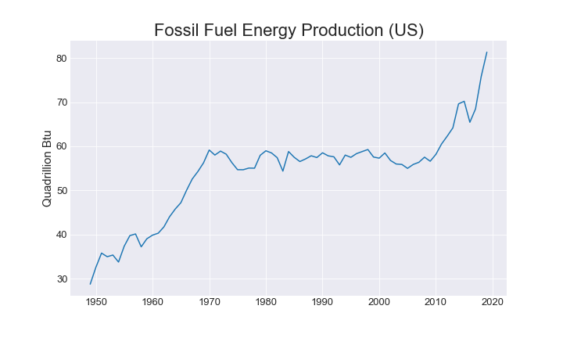

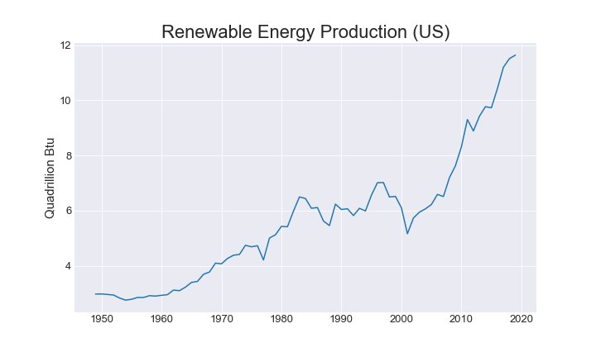

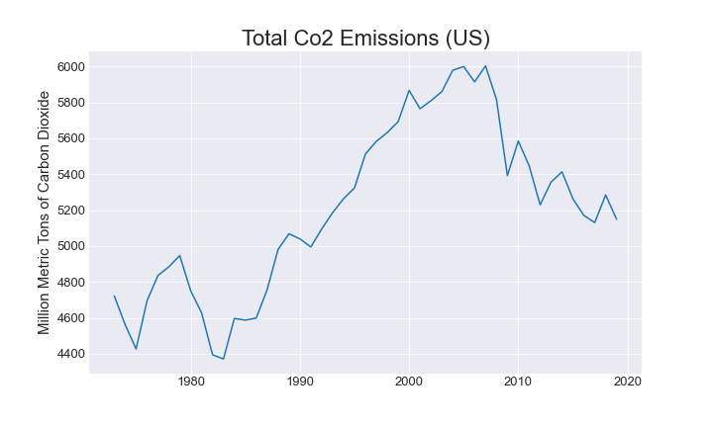

We can see here that both fossil and renewable fuel consumption has been increasing. While fossil fuel growth has been outpacing renewables growth in the past decade we have seen a decrease in overall Co2 emissions. Why is that?

*figure set (ii) [ [Data sourced from the U.S. Energy Information Administration]*

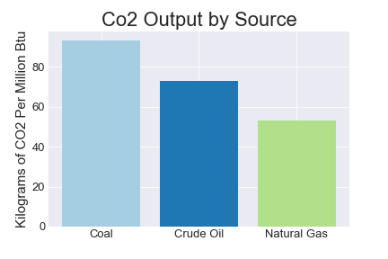

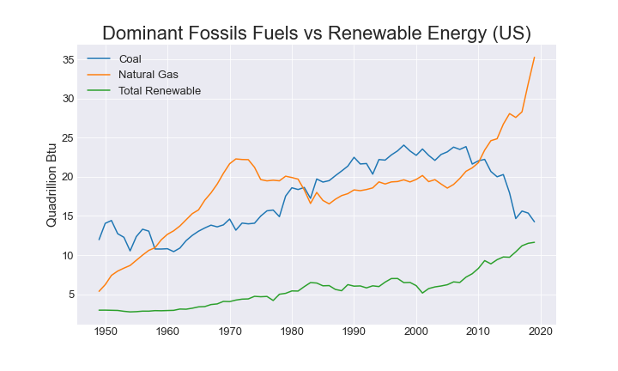

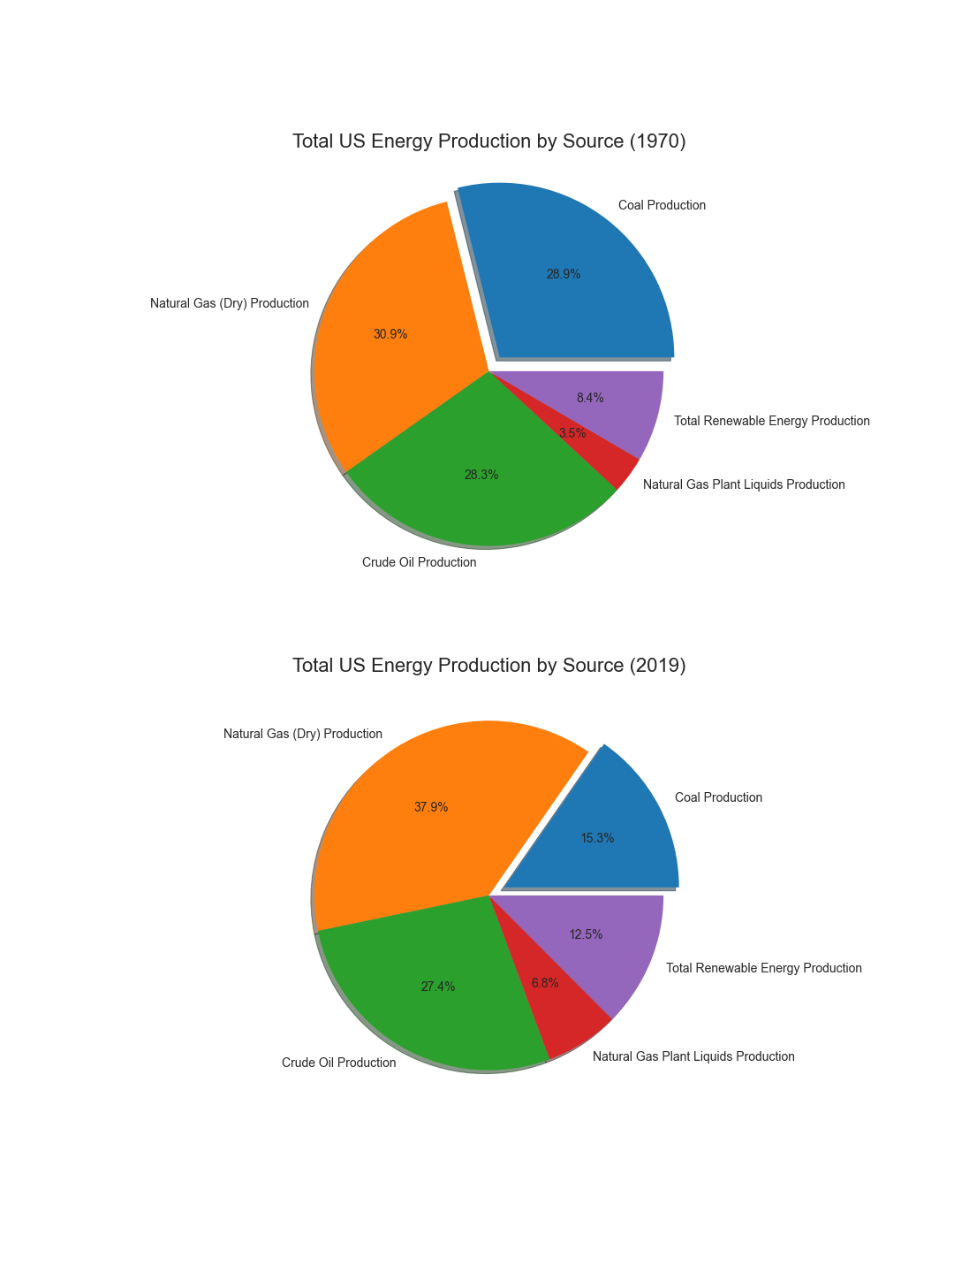

Over the past 50 years, the share of fossil fuel energy production occupied by coal, the highest emitter of Co2, has given way to natural gas, a much cleaner burning fuel. We do see an increase in renewables share in overall production as well which would also help drive down overall emissions.

Our analysis finds that the US is reducing its Co2 output. However, only a small dent has been made in overall emissions and further investment in renewables and a shift away from fossil fuels would go a long way to cutting emissions by a substantial amount.

## Electric Vehicles

Conventional combustion engines produce greenhouse gases as a result of burning fossil fuels. Moving to electric and hybrid vehicles could help reduce emissions and improve air quality in our nation’s cities. Have electric car sales made an impact on the air quality in cities around the United States?

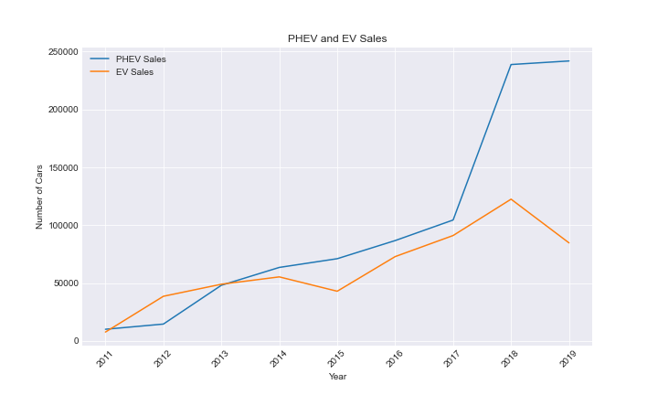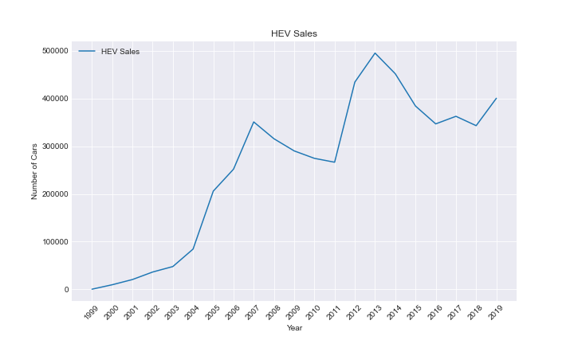

In the figures above, there is a general increase in Plug-in Hybrid Electric Vehicles, Electric Vehicles and in Hybrid Electric Vehicles from their initial introduction in the market by various makers, including but not excluded to Ford, Chevy, BMW, Volvo, Audi, Tesla, Nisan and Honda. The first PHEV was introduced in 2008 to the market. The first EV was the EV1, introduced and mass produced for the markets in the mid 1990s by General Motors.

*figure set (ii) [Data sourced from the EPA]*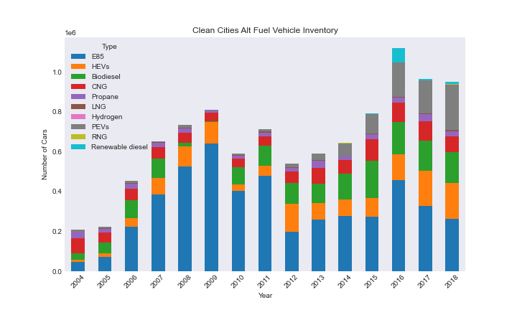

The figure above shows the number of Alternative Fuel car models in the market over the years from 2004 through 2018. E85, is an ethanol fuel blend is 85% ethanol fuel and 15% gasoline or other hydrocarbon by volume. HEVs are hybrid electric vehicles combining conventional internal combustion engines with an electric propulsion system. Biodiesel fuel is a form of diesel fuel from plants or animals by chemically reacting lipids. CNG is compressed natural gas. Propane is a by-product of natural gas processing and petroleum refining. LNG is liquefied natural gas. Hydrogen fuel is a zero-emission fuel burned with oxygen. PEVS are plug-in electric vehicles that can be recharged from an external electricity source. RNG is renewable natural gas and Renewable Diesel fuel is biomass-derived transportation fuel.

The Alternative Fuel data was taken from cities with clean energy and air initiatives. We can see an upward trend in manufacturing Alternative Fuel Vehicles, and an increase in numbers as more models are introduced.

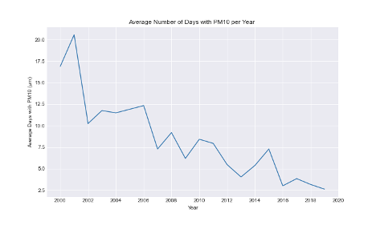

The figure above shows the Average number of days with PM10 from 2000 to 2019. PM10 is particulate matter up to the size of 10 micrometers. PM between 2.5 and 10 micrimeters are particles that are 25 to 100 times smaller than himan hair strand and are made from a different materials from different sources. Some particles are smoke, dirt and dust from factories, toxic organic compounds and heavy metals, and mold, spores and pollen. They are made from automobiles, burning plants, smelting and processing metals, crushed and grinded rocks and soil blown by wind.

The figure on the left depicts the Average Max AQI, air quality index, per year. A higher AQI means greater concern for general health. AQI values from 0-50 good or satisfactory air quality, an AQI from 51-100 is moderate or acceptable with some risk to sensitive people, an AQI from 101-150 is unhealthy for sensitive groups, an AQI from 151-200 is unhealthy to the general public, 201-200 is very unhealthy and there are health risks to everyone and lastly, 301 and higher is hazardous. We can see a clear decreasing trend line in AQI, meaning the air quality is improving.

The figure on the right shows the average number of days with good, moderate and unhealthy air in the United States over the years. There is an upward trend from 1980 to 2019 for average good days, a consistent trend for moderate days and a very little decrease trend in unhealthy days. The figure shows that air quality over all is improving as the average day has a higher chance of having good air quality.

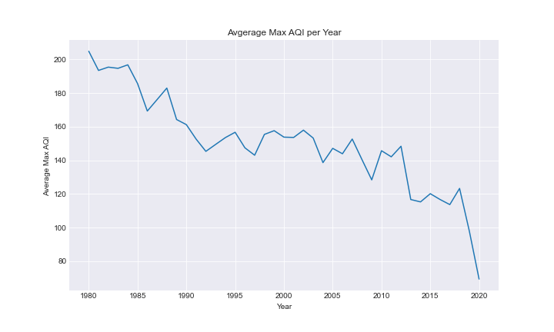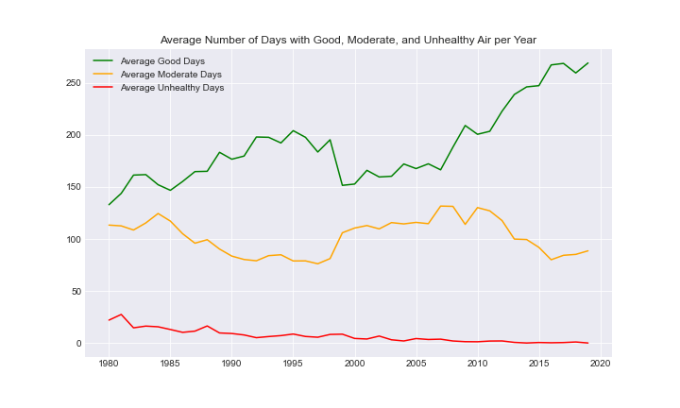

*figure set (iii) [Data sourced from the U.S. Department of Energy: Alternative Fuels Data Center]*

In the figures below we look at ten different cities in the United States; five with the top annually improved average good air quality days and five with the least annually improved average good air quality days. The first cluster of three figures shows Knoxville, TN, Medford, OR,Rochester, Ny, Syracuse, NY and Tulsa, OK as the top most improved average good air quality days. In the five, there is an upward trend in average good air quality days, a decreasing trend in average moderate air quality days, and a decreasing trend in average unhealthy air quality days, showing overall the air quality is improving.

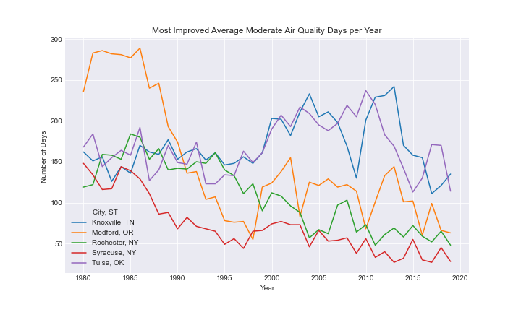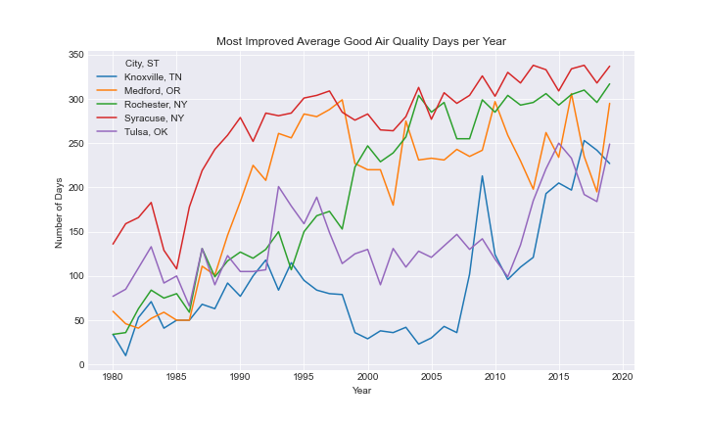

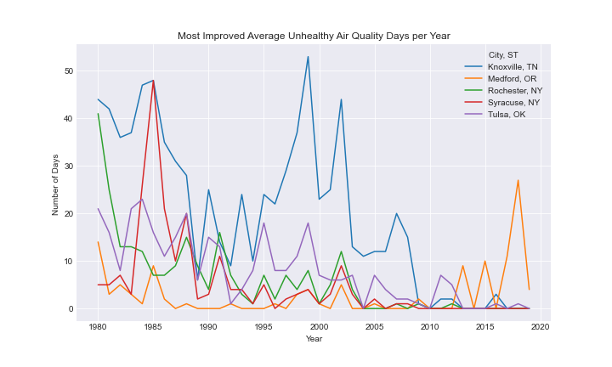

The next cluster of three figures shows the five cities with the annual least improved average good air quality days.The five cities depicted are Alburquerque, NM, Baton Rouge, LA, Fort Wayne, IN, Oklahoma City, OK, and Santa Fe, NM. From 1980 to 2019, there is little to no general improvement in the average good air quality days, a little general increase in average moderate air quality days and a general decrease in average unhealthy air quality days. Although there is a general decrease in average unhealthy air quality days, the average is scattered, with spikes and drops in various years.

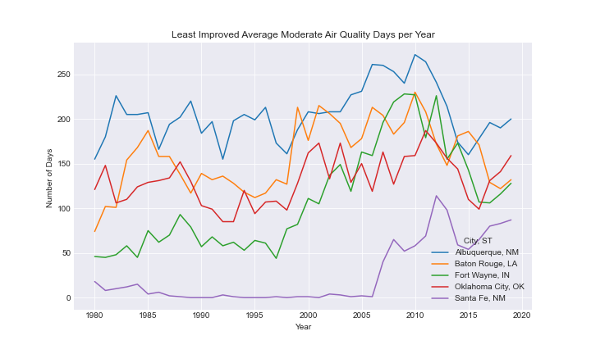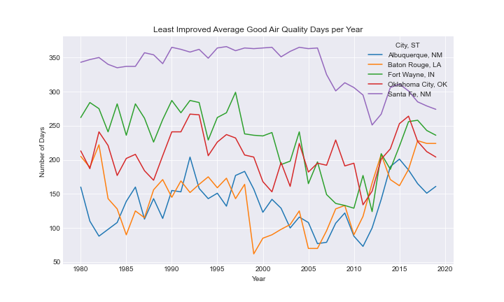

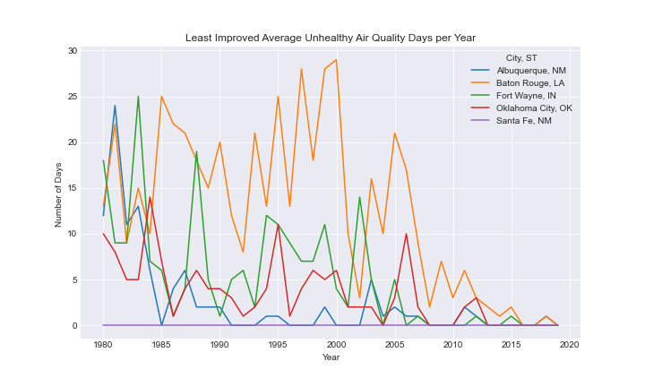

*figure set (iv) [Data sourced from the U.S. Department of Energy: Energy Efficiency and Renewable Energy]*

From the introduction of the electric vehicle to today, we can see a definite increase in manufacturing and in popularity. The electric vehicle is not the only alternative ‘green’ vehicle on the market nowadays, therefore the use of the alternative fuel vehicles have had an overall positive impact on the environment, specifically the air quality. With less emission of harmful air pollutants in EVs, PHEVs, HEVs, and alternative fuel vehicles we can conclude that they have had a positive impact on the general air quality.

## Education Attainment and Population Stabilization

Explosive population growth has been cited as a main cause of climate change. More people require more resources. Thus, providing for this increased population has put a strain on the environment. It has been observed around the world that population growth tends to level off as countries modernize. In this section we will take a look at one aspect of modernization, educational attainment.

Has increased educational attainment correlated with reduced reproduction rates?

Since 2010 the rate of population growth in the US has started to decrease. Is that attributed to the increase in education attainment?

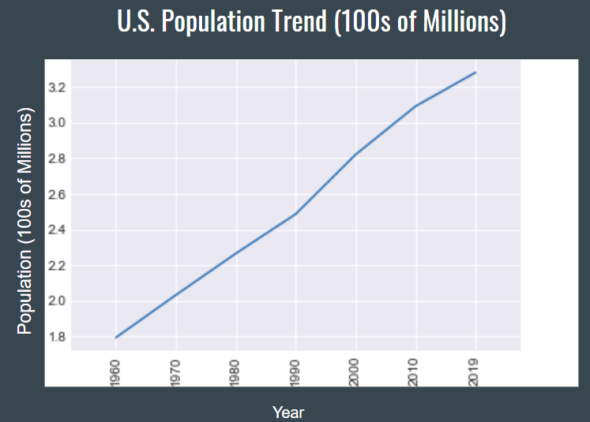

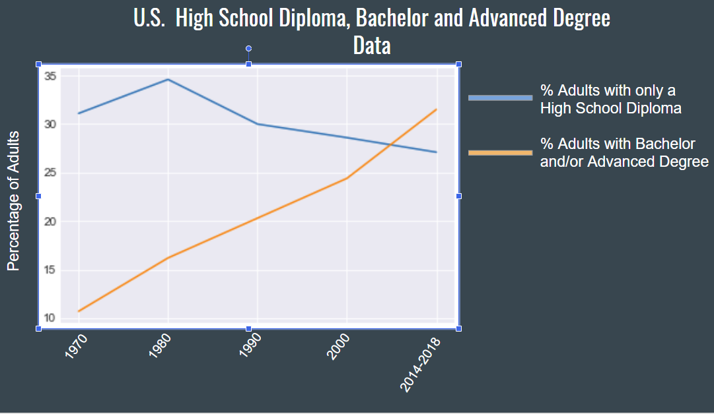

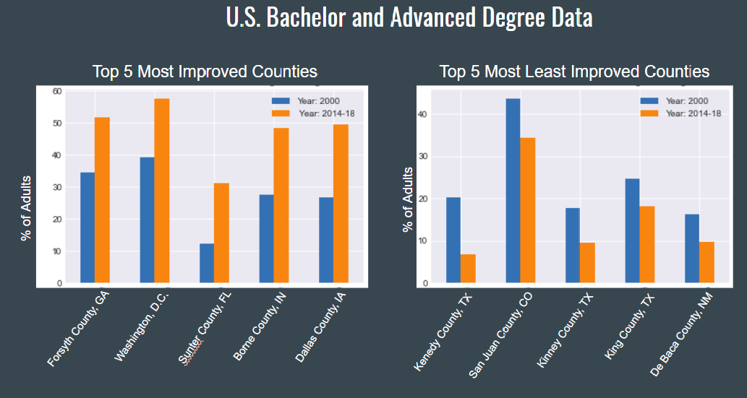

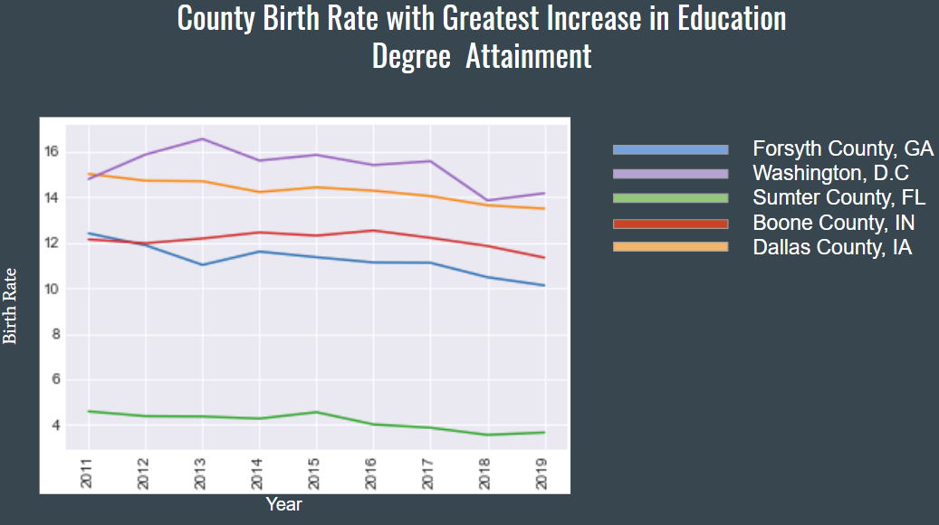

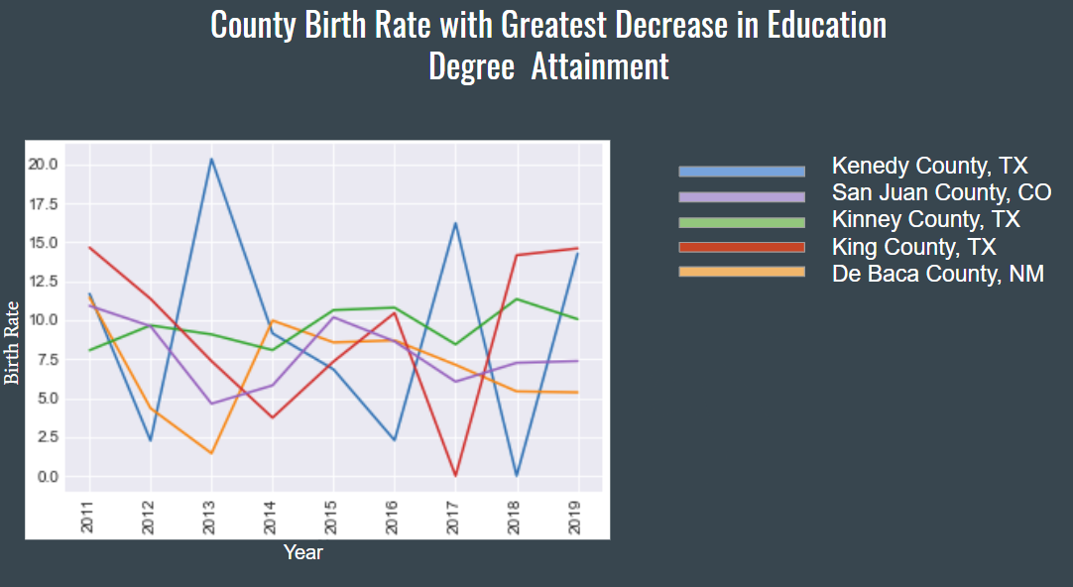

My hypothesis was not supported as the data shows high variability. If there was more time I would look into the migration rate, conception rate, and sex education within these counties.

## COVID Lockdowns and Air Quality

It is hard to get a population to change how they live all at once. The lockdowns in 2020 have provided an interesting window into how drastic change in a populations behavior may impact the environment.

As speculated in journalistic articles like these from early in the year of the onset of the Covid-19 pandemic, some of the largest effects of our climate change come from some of our everyday activities, such as flying, driving, and the way we eat. All of these activities increase what we call our “carbon footprint” on an individual basis. In fact, it was noted frequently in the news about the lack of traffic in normally heavily traveled areas.

However, in as little as a couple of months ago, we have started seeing a different story presented in journalism.

In order to look closer at how the pandemic has affected climate change, we followed the protocol used in this article published by the Guardian in August 2020.

We were able to obtain more up to date information all the way into November from Google, by tracking phone locations by date, and determining where people in the United States were in six different categories shown in the table below: Retail or Recreation (or in a public, indoor place), Grocery or Pharmacy (or shopping), Parks (or in a public outdoor place), Transit Stations (public transportation), Workplaces (meaning, at work), and Residential (or at home).

There was too much data in the dataset we obtained to study in depth due to time limitations. Therefore, we looked at the minimum and maximum movement among the states to determine which five states had the most and least movement per category on average per month.

Results:

Here we see the charts for the five states that had the maximum percentage change of movement of people in public indoor places over time, and the 5 states that had the minimum movement of people in public over time. Note that “Maximum” in public after the lockdowns began means people were out and about, and interacting inappropriately with one another, perhaps not physically distanced, and spreading the virus. We see that in April, there was a huge decline in all of these states in terms of people going to indoor spaces. Looking at the maximum movement, there was a big drop from February to April, but then states like New York and New Jersey had a pretty quick increase in percent change of movement within the next couple of months, with all states slowing flattening out, but staying in the negative numbers (meaning less people were seen in these spaces).

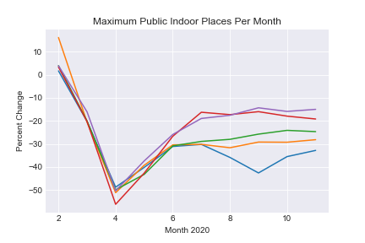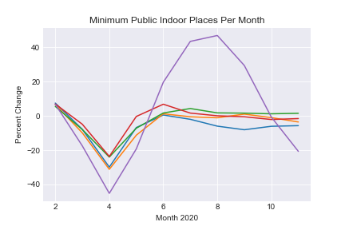

A similar trend can be seen for April on the five minimum average percent change states in the lower graph, but they rose just as quickly thereafter and did not start with as high of movement to these places to begin with as did the states with the maximums. Interestingly, Wyoming stood out as the outlier here, with movement increasing much higher by July or August. We could hypothesize here that there are few people with a lot of real estate in Wyoming, and perhaps they felt safer to move around like this.

In our next set of graphs concerning percent mobility for people who were out shopping, we see a similar trend, but with different states. There was a big drop in April, with a slightly smaller increase before leveling off. We would have to study more data to determine why shopping was quicker to slow in movement on average than public indoor spaces, but we could hypothesize that it was the use of services or delivery for this category.

# 

# The top minimum mobility states here are starting already at lower average percentages for movement in the shopping category. It isn’t clear why that is the case, but they did not have far to go to drop to the lower percentages. Once again, Wyoming had a large increase throughout the summer. This could be weather or population related.

# The maximum percentage top states for movement to outdoor places, such as parks, did not present as much of a clear trend after April. Some of these states seemed to never stop going outside much, but as we near the end of the year, we can see most of them going down again with the onset of winter.

# 

# Minimum average percentage states started out with very low rates of spending time outside int the first place, so we see this trending up substantially over the summer months, and then back down again during as it got colder.

# These graphs show the maximum and minimum average percentage of movement in transit stations for public transportation. Our states with the maximum average percent were not using public transportation that much to begin with, and we see the common trend to the deep negative values in April, with a slight trend back up shortly thereafter, and then somewhat leveling off.

# 

# States in the minimum percentage movement category also started off with very little activity in this area to begin with, then a trending upward, with states like Wisconsin, Ohio, and Virginia moving back to the original movement pretty quickly, and even West Virginia showing this trend as well with a slight movement downward more recently. Once again, Wyoming is the outlier here, with very little use of public transportation (which would be typical for a rural state), but then had a wide swing up to positive averages during the summer months with a quick decline leading into winter. We could hypothesize that this could be a result of tourists in this location.

# Finally, we compare percent average movement to work or staying home. The graphs below indicate that we likely did not have data for this movement, or it was not provided, for the beginning of the year. However, we see in both instances, substantial downward trends in April, with the slow trending back upward as the year went on. We do see that even though the states that had more movement were lower than those with minimum movement. This could be because the states that are in the maximum category here are known for industries where people already work from home, doing work in technology or farming.

# 

# 

And to see a very opposite trend from all the other graphs above, we see a large spike in both graphs here, in April, where people were staying home a lot. Presumably, this is because many people were transitioned into working from home, temporarily or permanently closed their businesses, or were laid off. This would explain the difference between the substantial increase in people being at home in our maximum movement states versus the higher increase in states, again like California or New York, where people may be already working from home.

*figure set (V) [Data sourced from the Google COVID Mobility Data and The Guardian]*

COVID Activity CONCLUSION

Overall, we saw interesting trends in all categories across the board. We had very little data on the movement people in the dataset prior to the beginning of the pandemic. However, we see deep declines across the board for the states represented here in all categories in April, when the virus was at its first peak, and states began taking measures to prevent spread. We also see major increases in people staying at home, but others not really avoiding travel. Less people were seen to be going to indoor locations and especially shopping, however there were increases in travel to outdoor spaces, particularly during summer.

Notably, Hawaii was the only state that appeared in every graph that indicated a lack of following CDC guidelines during the pandemic, if we were to base that solely off the Android data. Louisiana was a frequent offender, and sometimes, so was California. Likewise, rural states like Wyoming and Virginia appeared to have less movement on average by Android users.

It also should be noted that we were not able to utilize the Apple data to examine the movements of iOS users, because their data were quite different in categorical information. We hypothesized that this might be because Apple tends to keep its data closed more often than Google does.

# Conclusion

A sluggish transition away from fossil fuels does not seem to be adequate in reducing overall Co2 emissions by a large enough margin. Population growth seems to be leveling off by a small amount but not yet stabilizing. We did not find that increased educational achievement had an effect on reproduction rates. There is some heartening evidence of local initiatives providing good results in the form of improved air quality. The data regarding environmental effects of nationwide lockdowns seems to suggest that the sources of greenhouse gases are only mildly impacted by the habits of individuals.

Our data shows that local governments can lead people to make positive changes in their habits that have a real positive effect on the environment. If the leadership of these clean cities could be applied to the energy sector we may see a more pronounced change in Co2 emissions.